2017 Spring VIP AAV Image Processing Development Notes

Main Contributor:

Guanghua Zha:)

[gzha@purdue.edu](mailto:gzha@purdue.edu)

**0. Introduction:**

This is the drone at end of last semester. This is the drone at end of this semester.

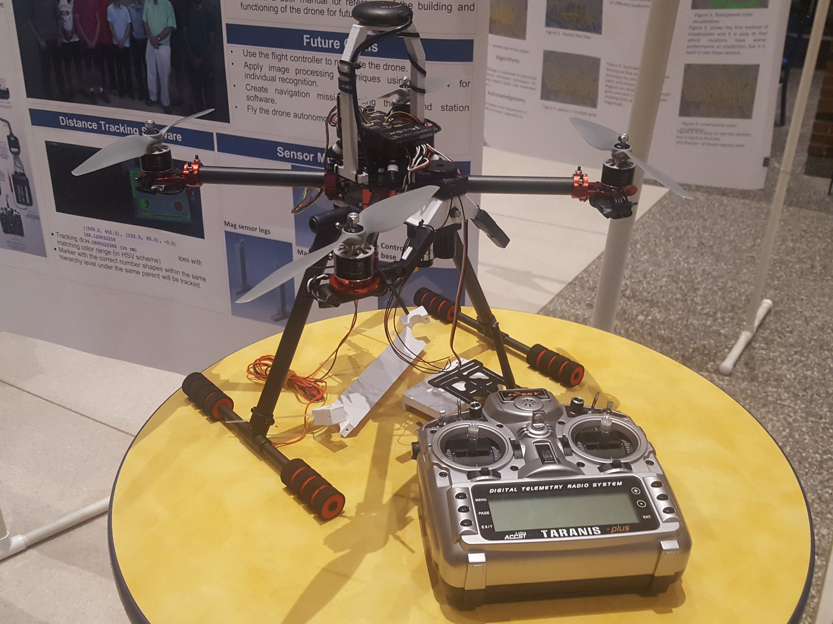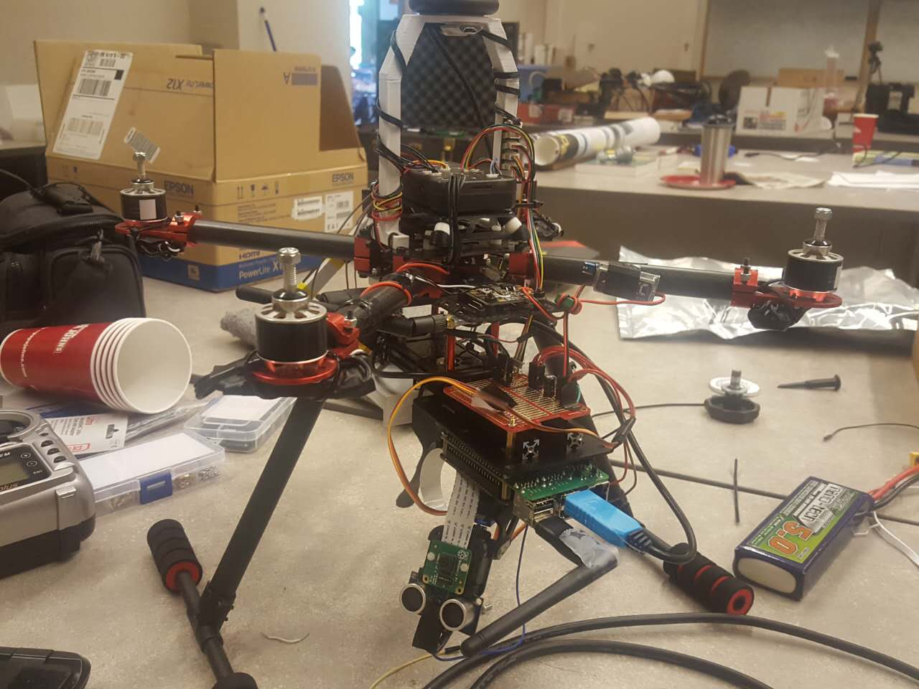

This will be a very long documentation. I will work you through all stuff we have done in 2017 Spring.

1. **Connection from computer to the Raspberry Pi**

There are several ways to connect to the Raspberry Pi.

1. Connect a display via HDMI port, a keyboard and mouse. (Connect the display via HDMI before power on the R Pi. Otherwise the display will not turn on)
2. Use your computer as a console and connect to R Pi. There are three ways in this case. (**all for windows machine**)

(i) Connect the R Pi to a laptop through **ethernet cable**. Then open a command prompt. Type ‘arp -a’ then press Enter. It will show you something like this:

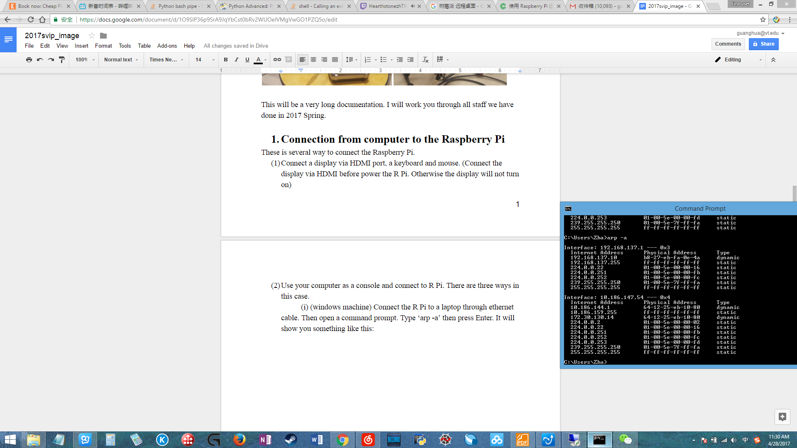

Notice that the IP address of the R Pi is the first one 192.168.137.10.

Now open the application ‘Remote Desktop Connection’ and type in the IP address we found above.

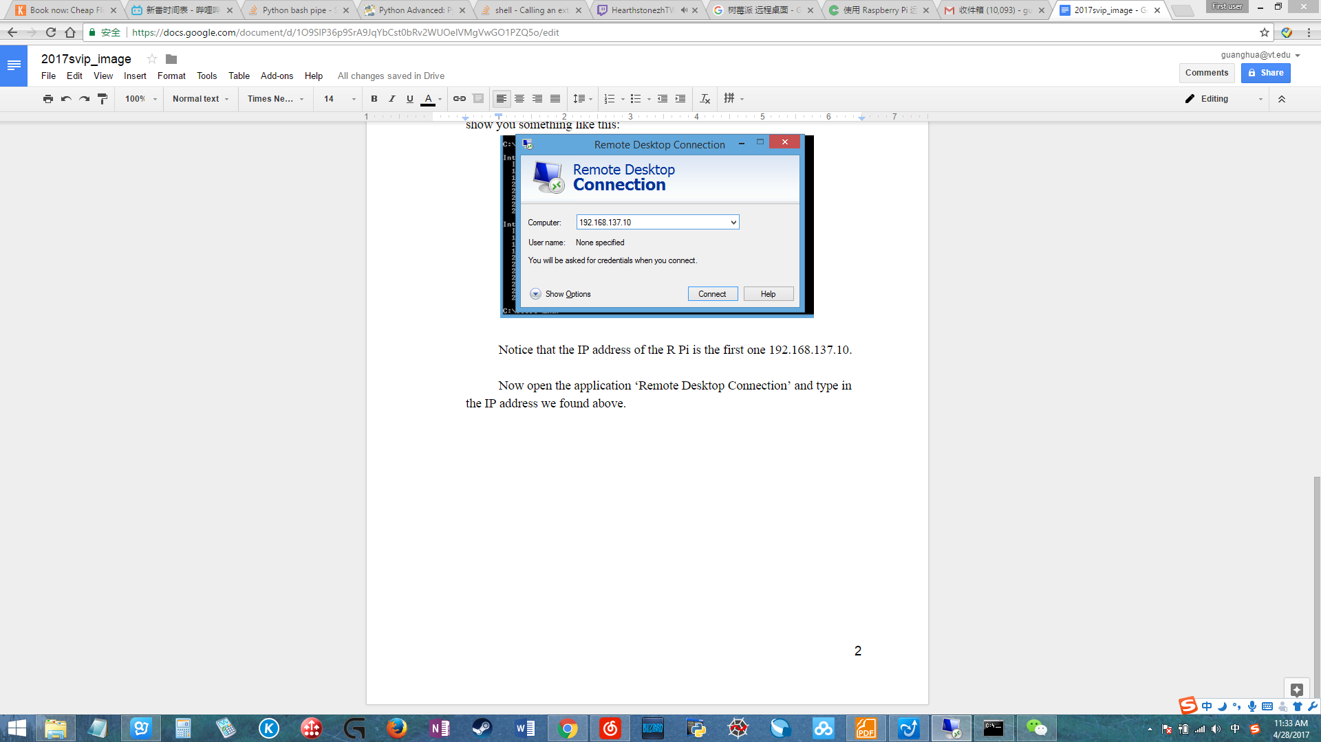

Before we connect click ‘show options’ then navigate to the tab ‘Display’:

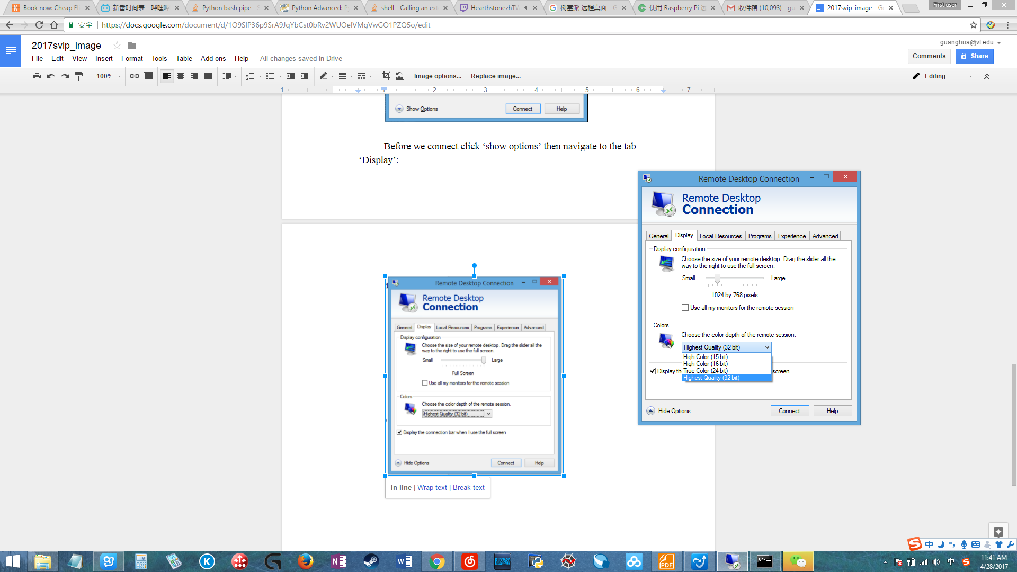

Change the setting above to reduce ***latency***. Notice for ‘colors’ the best option is ‘**High Color (16 bit)**’. The ‘High Color (15 bit)’ will have almost no latency but all pictures will show as black. Try the ‘Highest Quality(32 bit)’ and you will know what I mean by ‘***latency***’.

Then go back to ‘General’ tab. Press ‘Connect’:

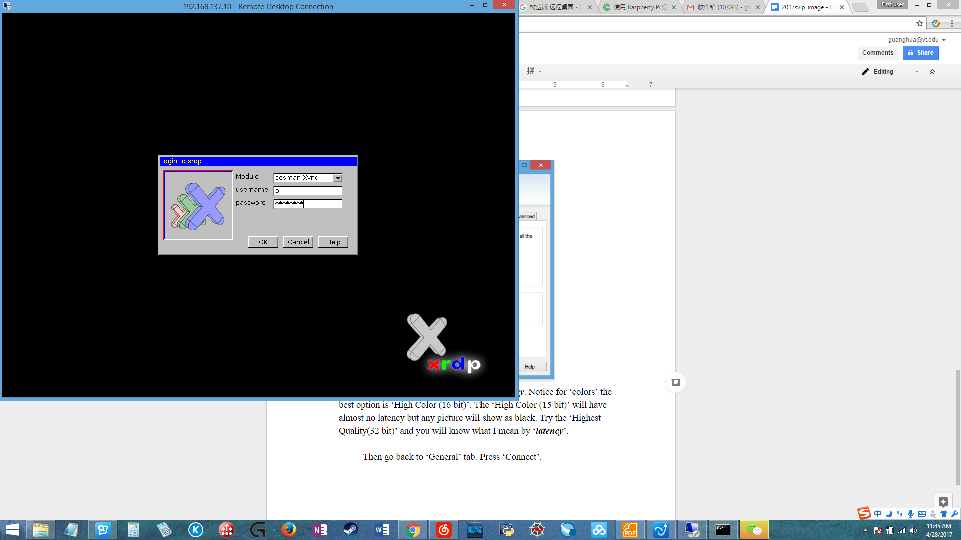

**username is ‘pi’**

**Password is ‘2017svip’**

All in lowercase.

Notice all the password in this R Pi should be ‘2017svip’ include the root password. Then you will connect to the desktop of the R Pi.

(ii)During the test flight we need to connect to the R Pi through WLAN. Currently there is a WIFI adapter installed on the R Pi and that device is configured as a **hotspot**.

The guide is

<https://frillip.com/using-your-raspberry-pi-3-as-a-wifi-access-point-with-hostapd/>

We also try this link but it is not working:

<http://spaces.ac.cn/archives/3728/> (In Chinese)

We might also tried something else but we cannot find the link anymore. So far we have not seen any problem due to those changes.

When the R Pi boot up R Pi will connect itself to the hotspot called ‘**wifi_tester**’. (if you connected the R Pi to some other network like ATT, remember to **modify the file on** ‘sudo nano /etc/wpa_supplicant/wpa_supplicant.conf’ and make it looks like the figure below(delete all other network))

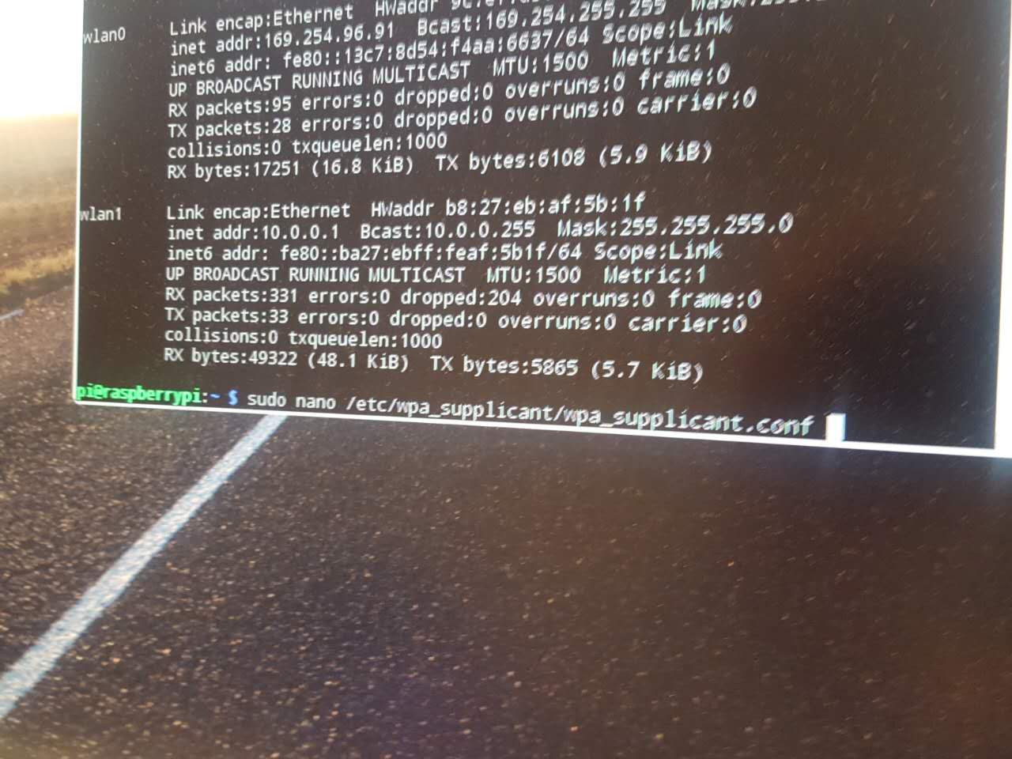

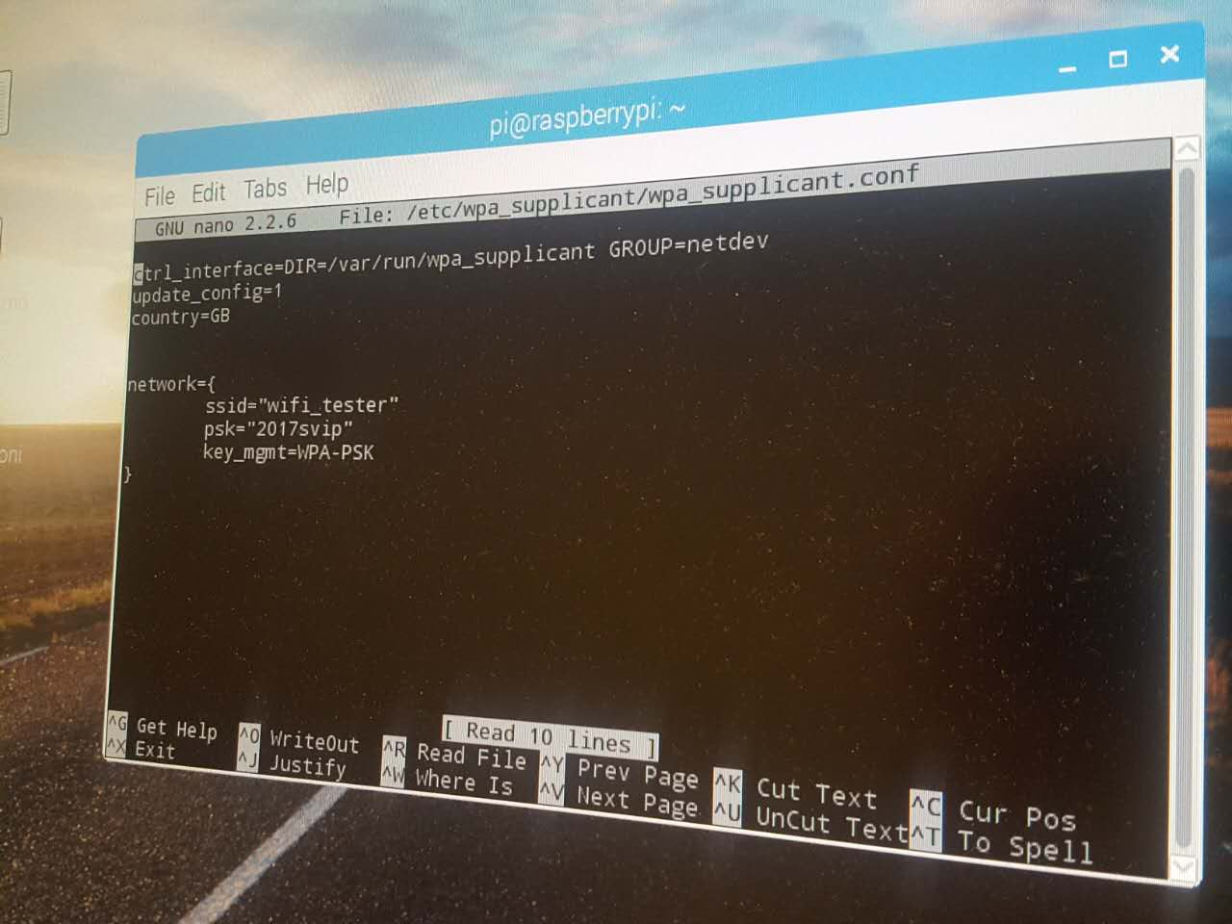

Now connect your laptop to the WIFI named **‘wifi_tester’**.

**Password: 2017svip**

This time we will **not** use the address in ‘arp -a’.

Type ‘sudo ifconfig’ in the R Pi terminal then press enter.

Find the interned addr for wlan0.

What I have seen so far is that this will be a static IP address which is:

169.254.194.122

Then follow the procedure same as (i) to connect to R Pi through ‘Remote Desktop Connection’.

(3) This R Pi is ssh enabled. You can always ssh into the R Pi when R Pi and your computer connected to the same router (that’s why we set up a wifi hotspot). You need to download some ssh software like Putty; Then connect to pi using it’s IP address. (Port 22)

Another way to connect to graphic interface is through VNC. You need some software like VNC-Viewer. **Before you link VNC you need to issue the command ‘tightvncserver’ in the R Pi terminal each time it boot up. So the procedure is: Boot up / wait for adapter boot up / SSH to R Pi / issue command / connect via VNC. (Port 1)**

However, there is huge latency when using this way. Better use (2) instead.

**2. Parts.**

Here is all the parts that we used and brief description of their function.

* R Pi Charger: <https://www.amazon.com/gp/product/B01IHU0CEI/ref=oh_aui_detailpage_o08_s00?ie=UTF8&psc=1>
* Wifi adpter: <https://www.amazon.com/gp/product/B004AC0L4Y/ref=oh_aui_detailpage_o04_s00?ie=UTF8&psc=1>
* Hardware PWM: <https://www.amazon.com/gp/product/B014KTSMLA/ref=oh_aui_detailpage_o00_s00?ie=UTF8&psc=1>

Instead of using this board we use another PWNM hat since it can be used to hold the pan-tile model. However, I still prefer this PWM driver since it has better performance.

* R Pi prototype board: <https://www.amazon.com/gp/product/B013SPEXSI/ref=oh_aui_detailpage_o01_s00?ie=UTF8&psc=1>
* Pan-Tilt-Hat: <https://www.amazon.com/Pimoroni-Pan-Tilt-Full-Micro-Servos/dp/B01N5E3I3W>
* Pan-Tile servor and frame: <https://www.adafruit.com/product/1967>
* HDMI cable: <https://www.amazon.com/gp/product/B014I8UU2W/ref=oh_aui_detailpage_o07_s00?ie=UTF8&psc=1>
* R Pi camera: <https://www.amazon.com/gp/product/B01ER2SKFS/ref=oh_aui_detailpage_o08_s00?ie=UTF8&psc=1>
* Longer R Pi camera cable: <https://www.amazon.com/gp/product/B00I6LJ19G/ref=oh_aui_detailpage_o02_s00?ie=UTF8&psc=1>
* Absolute direction sensor:

<https://www.amazon.com/gp/product/B017PEIGIG/ref=oh_aui_detailpage_o05_s00?ie=UTF8&psc=1>

Tested but not integrated on board due to the limit of time.

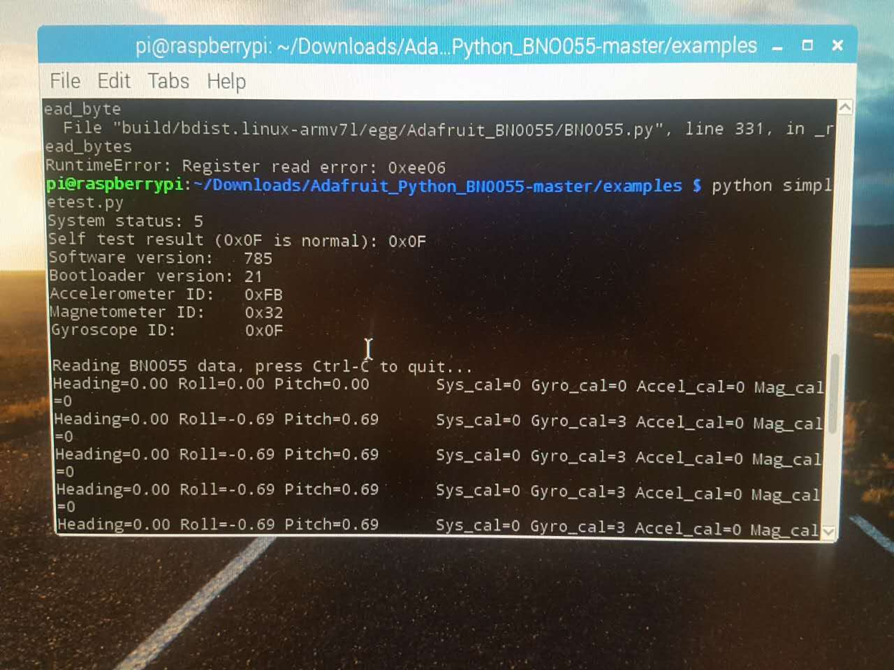

* USB to TTL serial cable: <https://www.amazon.com/gp/product/B00QT7LQ88/ref=oh_aui_detailpage_o09_s00?ie=UTF8&psc=1>

We have two devices need to use the UART serial connection. However, the R Pi only provide one. This is the extra UART port that connect Raspberry pi to Pixhawk. **Connection: Yellow to pin2, green to pin3, black to pin6.**

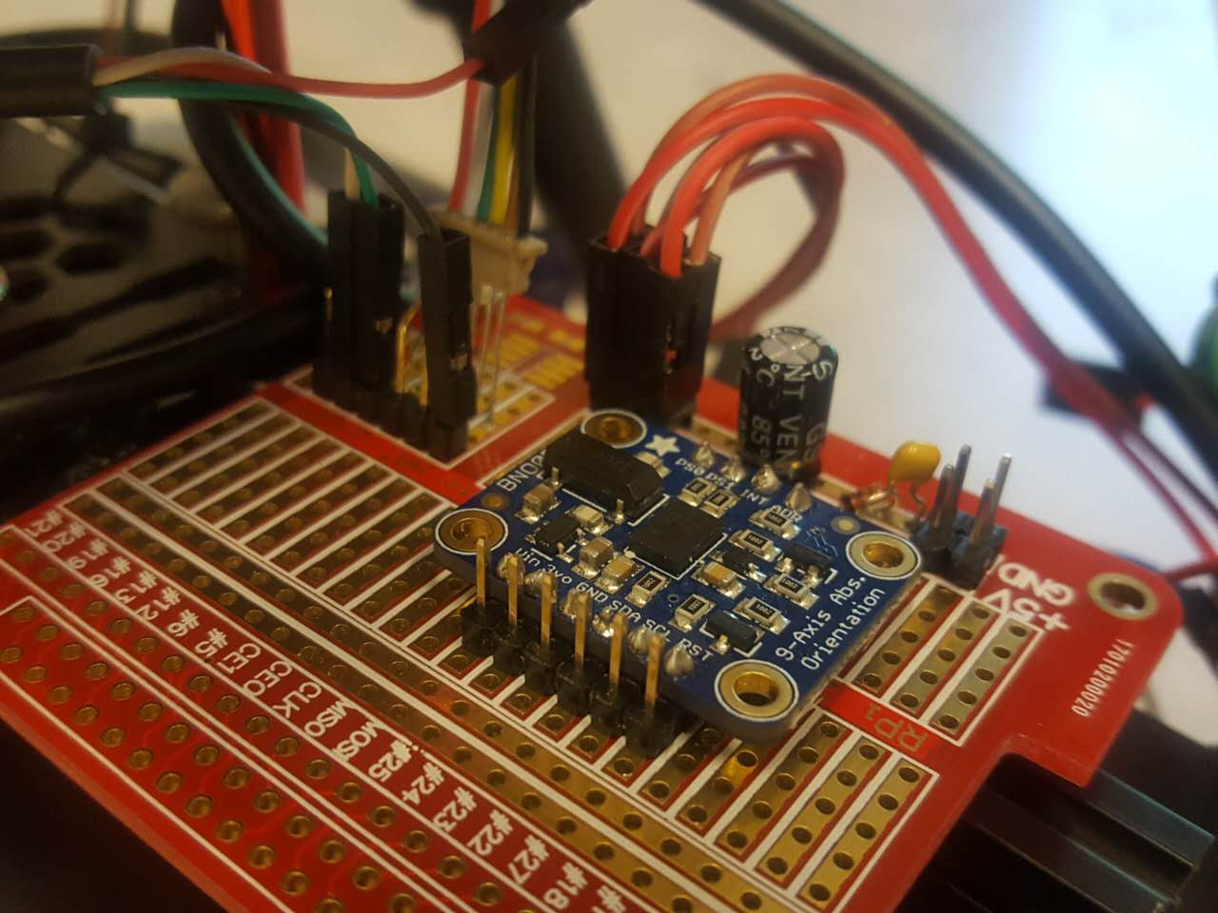

Currently this cable is broken. Please buy a new one :D

# PING))) Ultrasonic Distance Sensor: <https://www.parallax.com/product/28015>

Bought from mouser.com

* Spacer: <https://www.amazon.com/gp/product/B01L06CUJG/ref=oh_aui_detailpage_o01_s00?ie=UTF8&psc=1>

**3. Connection and assembly.**

**Prototype board:**

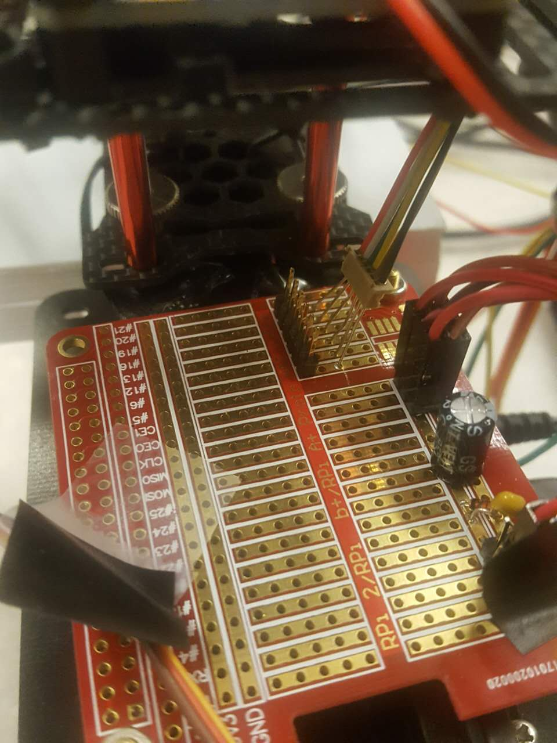

On the right side is when the 5v source connect. The 5V source is provided by the drone’s power board. The 5v is used to power the R Pi, two servos in pan-tilt module, and the lite lidar range finder. There is a protection diode, a 47u electrolytic capacitor and a 0.1u capacitor to stabilize and protect the voltage source. The absolute direction sensor also suppose to be place at here. Please solder some female header and put the sensor in.

Disconnect the power in from the Drone if you power the R Pi using external power through USB. Also be careful of polarity of the power source.

Absolute direction sensor: BNO055

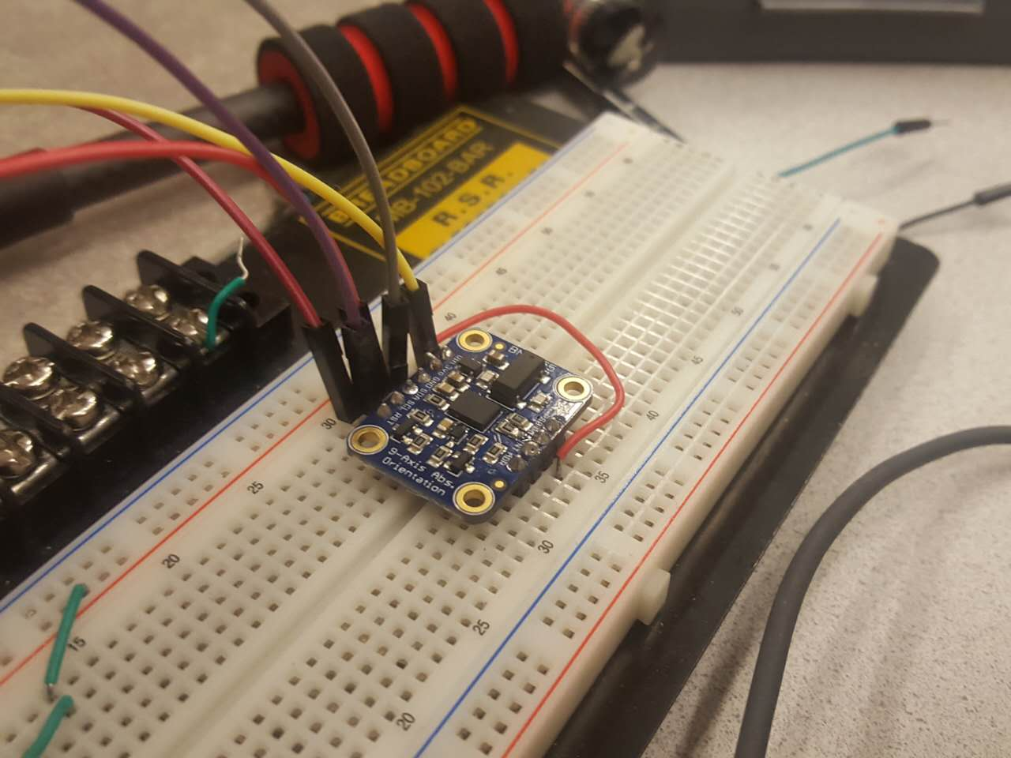

See in the link: <https://learn.adafruit.com/bno055-absolute-orientation-sensor-with-raspberry-pi-and-beaglebone-black/overview>

This sensor suppose to use to detect the movement of the drone to see if the drone in the right movement also record the flight data. Also should be used to work along with the pan-tilt module to stabilize the movement of the camera.

Also this sensor use 3.3V as input.

Pan-tilt-hat:

Top Bottom

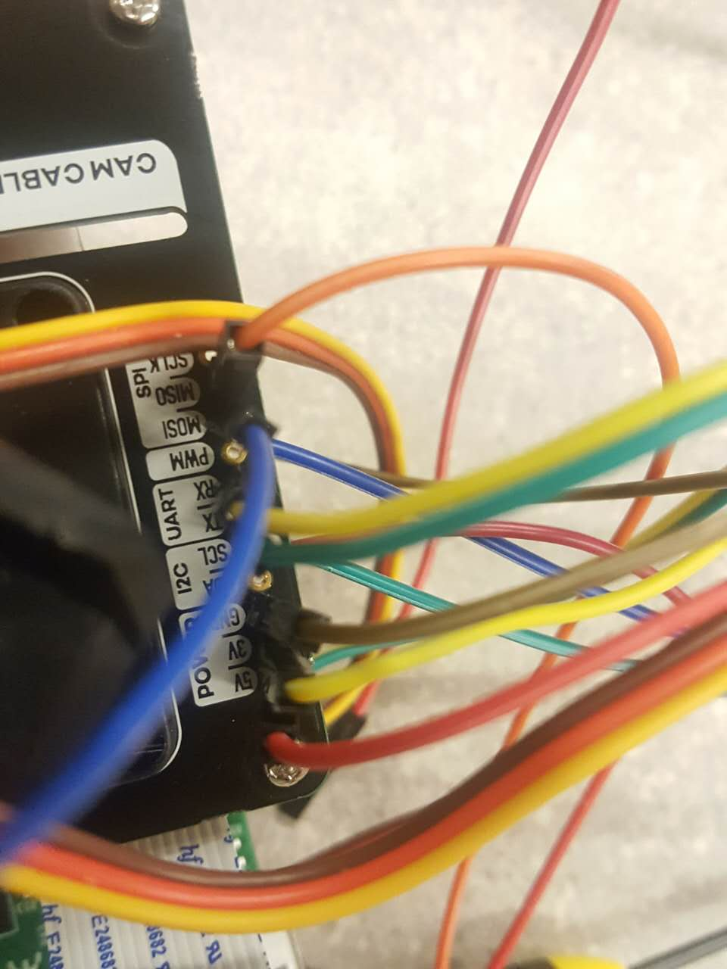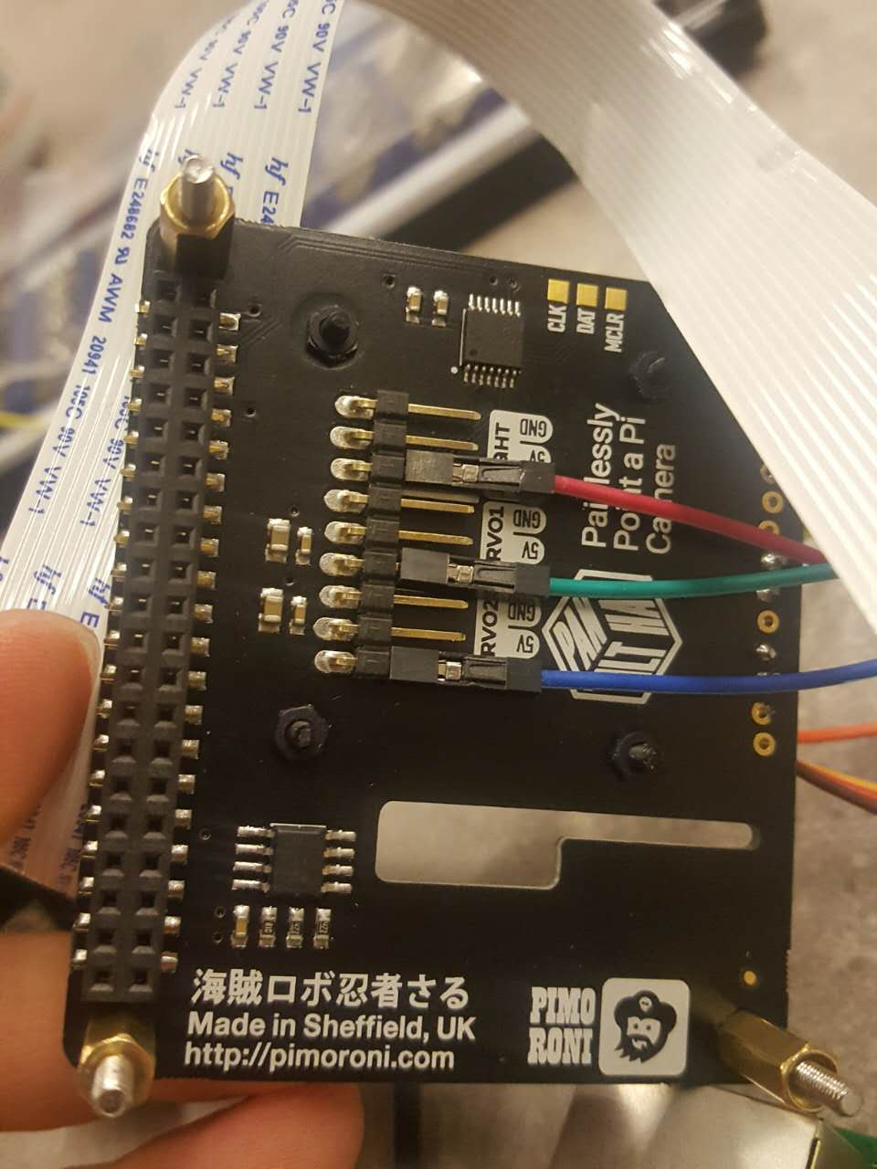

We did not find any document that illustrate which are these pinout with respect to the Raspberry Pi GPIO. The two servo work with the library download from the manufacture. However, we can guess some pinout by their function (suck like MOSI is pin 19) <https://pinout.xyz/>

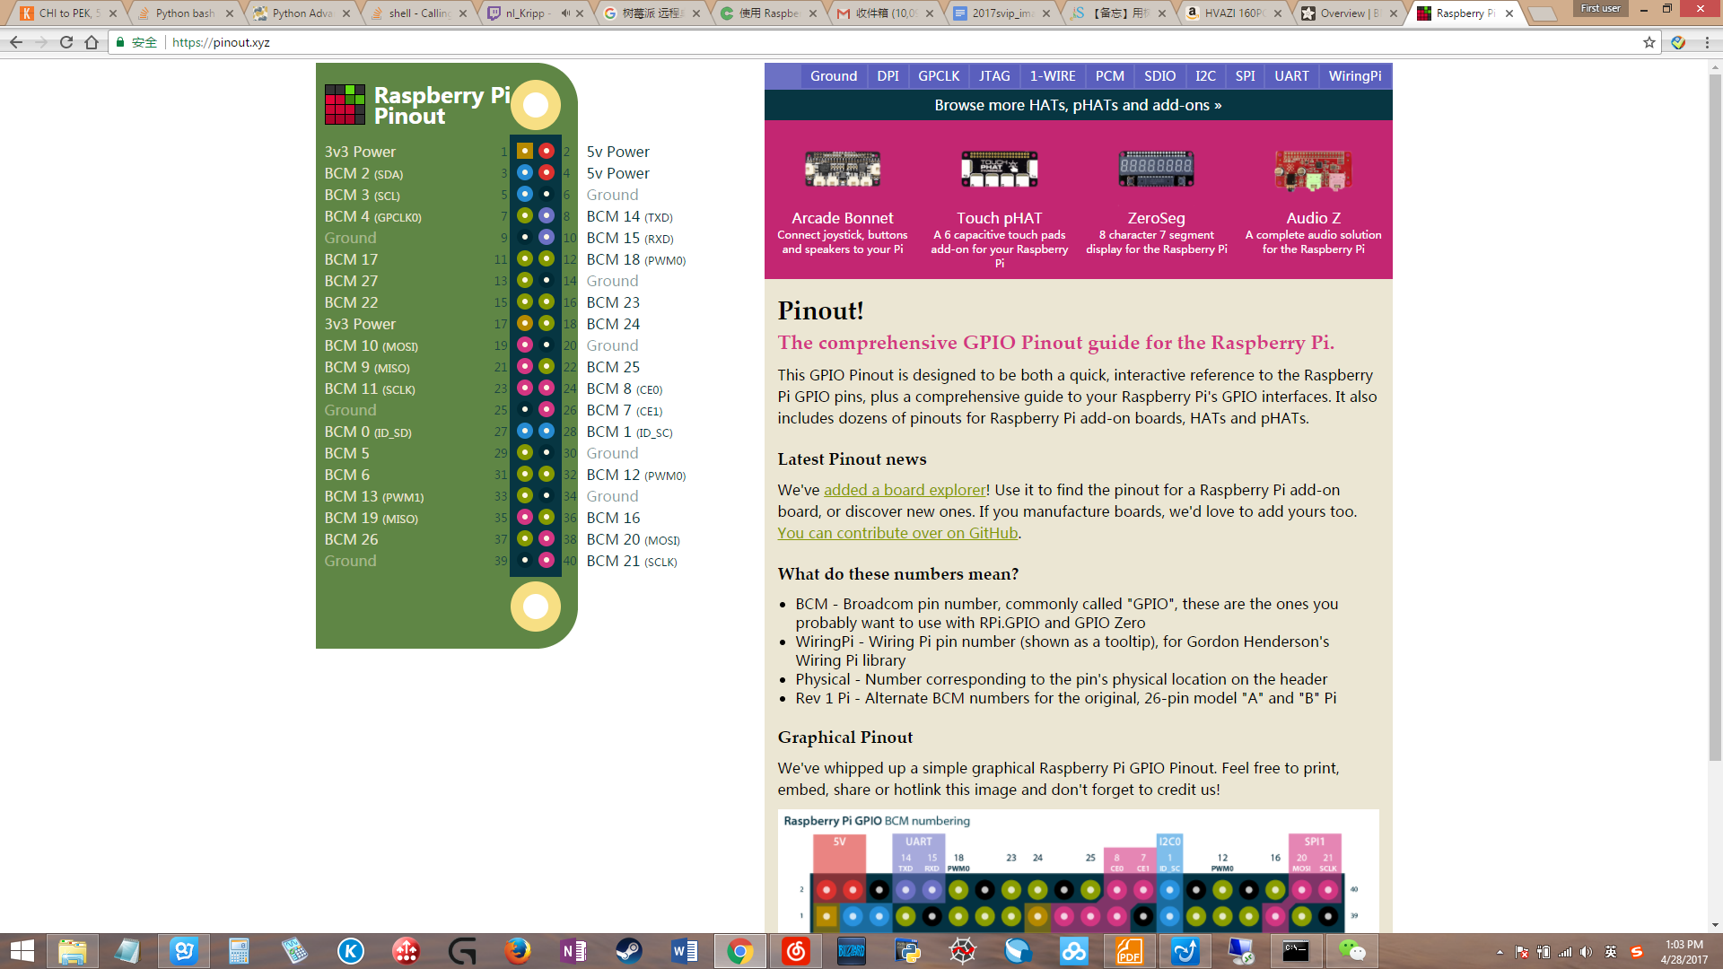

**The MOSI (pin 19) is the signal input of the ultrasonic distance sensor. The UART port suppose to be connected to the absolute direction sensor.**

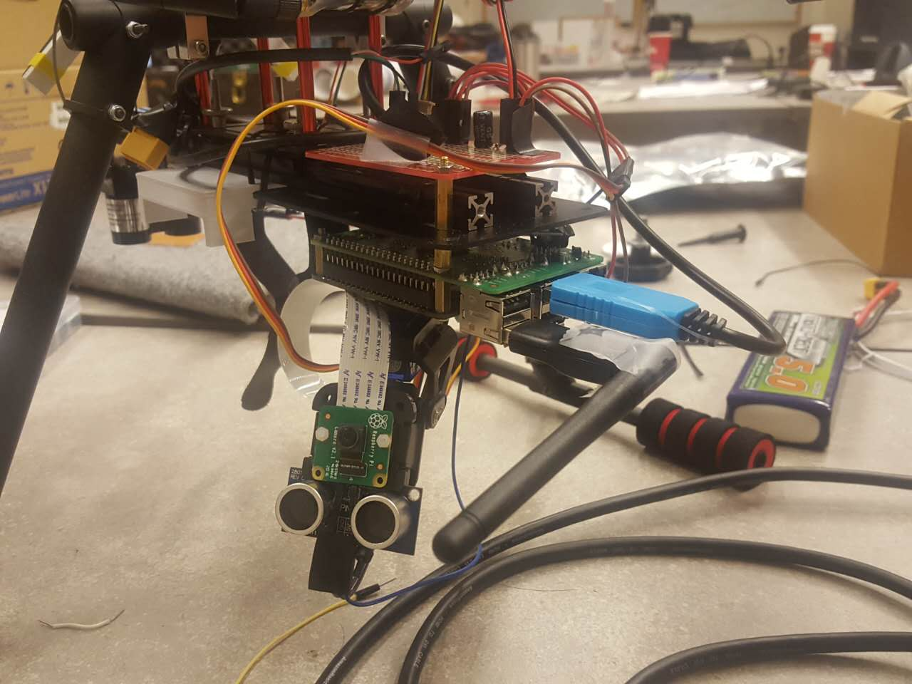

The camera and the ultrasonic sensor was not designed to be placed like this. It was designed by me. So far so good. Note there are two zip-ties that tie the ultrasonic sensor with the pan-tile frame.

Installed the R Pi on the drone:

Notice that the screw size for R Pi is 2.5. Other screw on the drone is 3.

1. Connect the camera to R Pi.

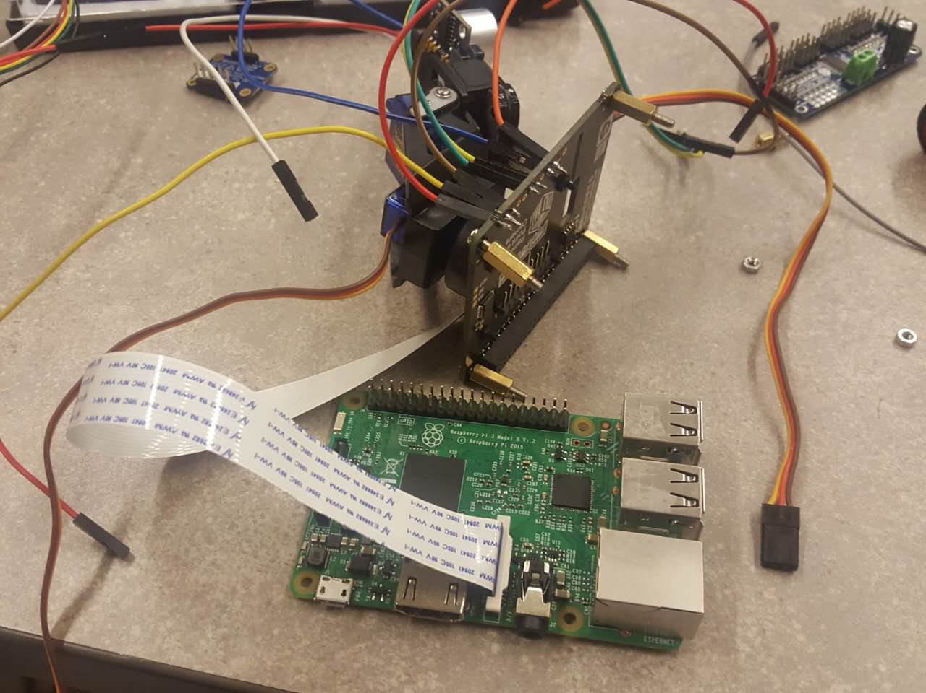

(2)Put the hat on the R Pi and nut on bottom. Notice only three have nut.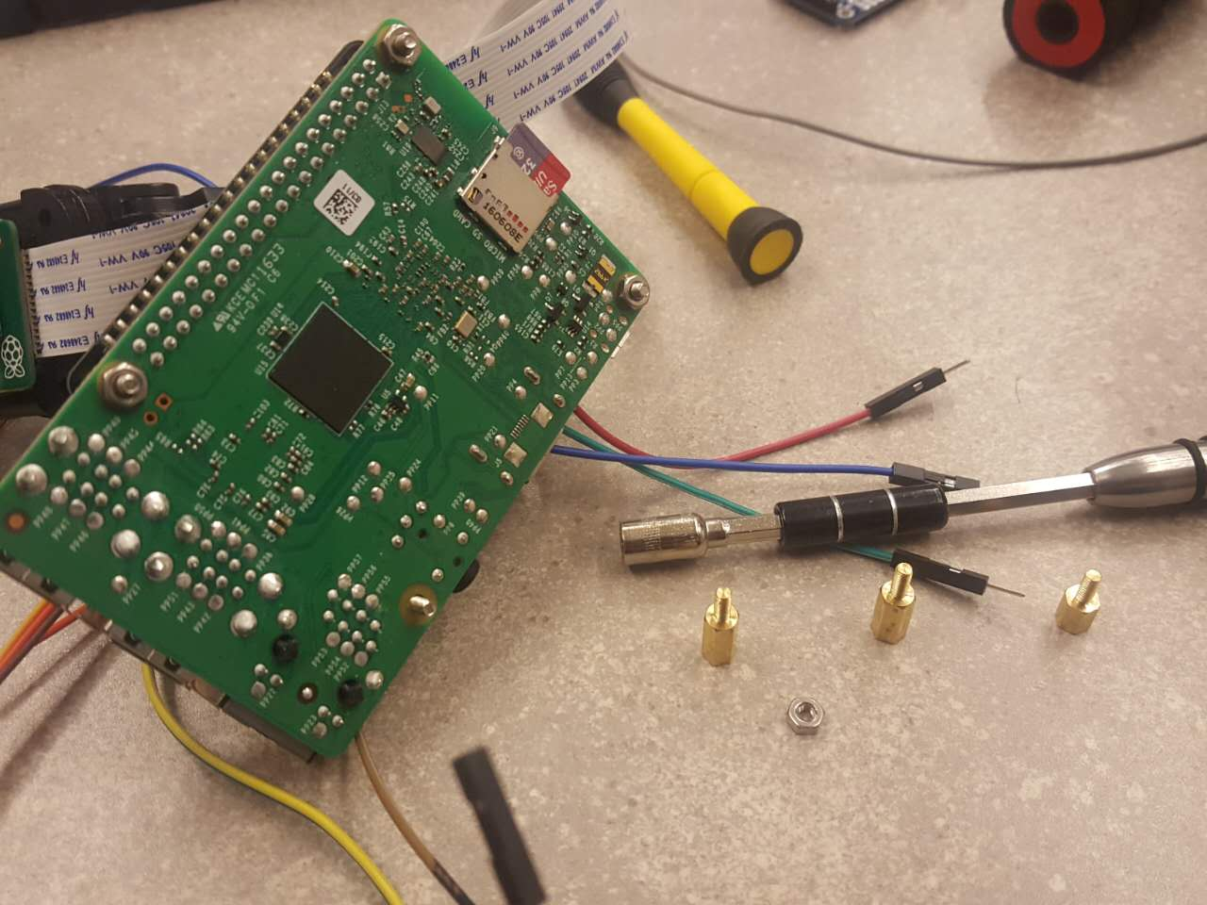

(3)Put spacer on. Note one is different from the other two.

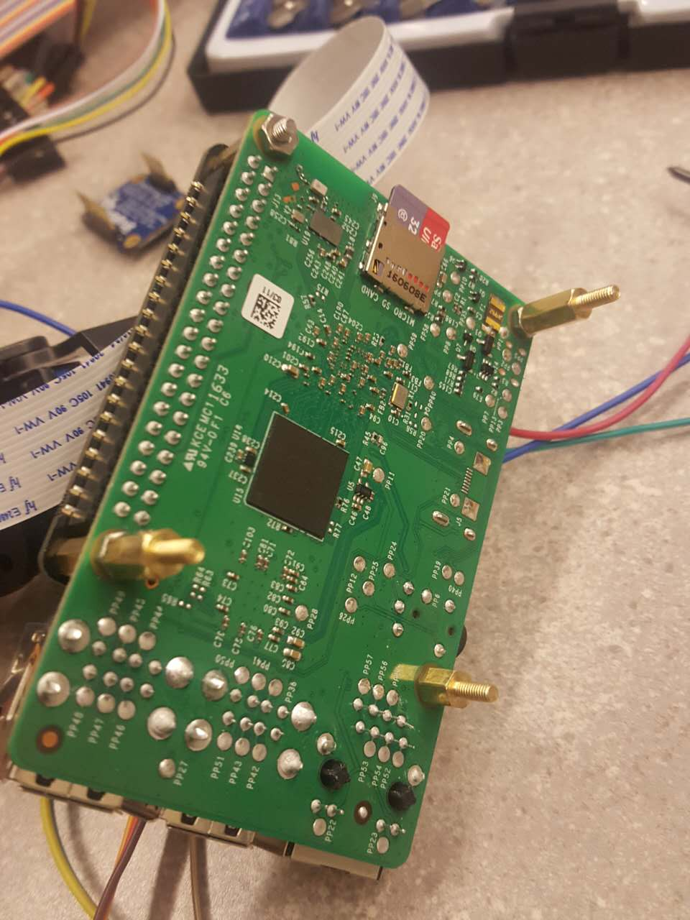

(4)assemble this T frame. This part is from another project of mine.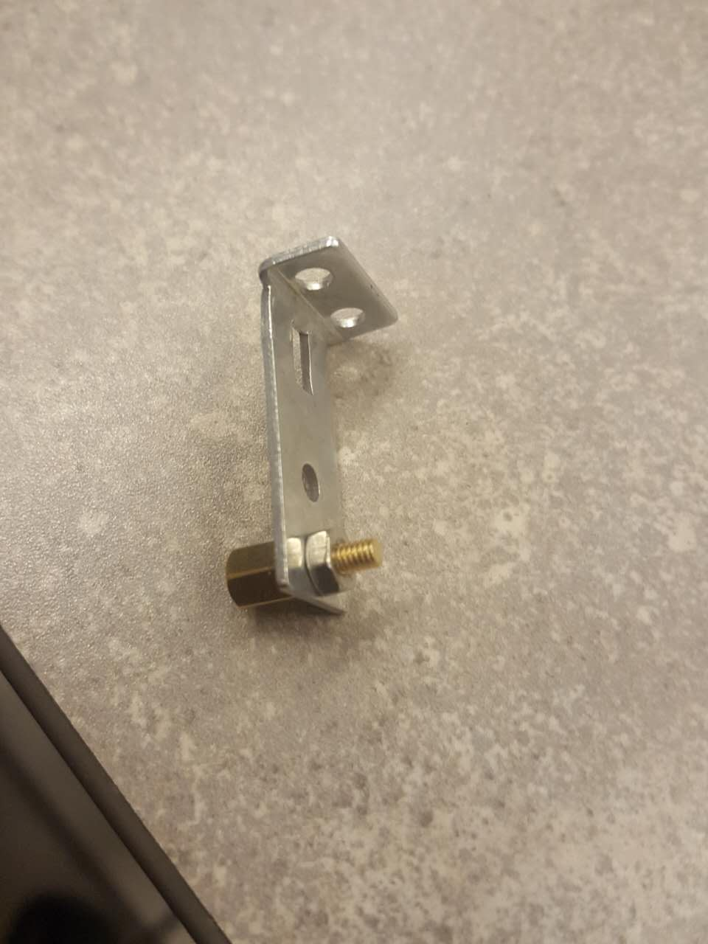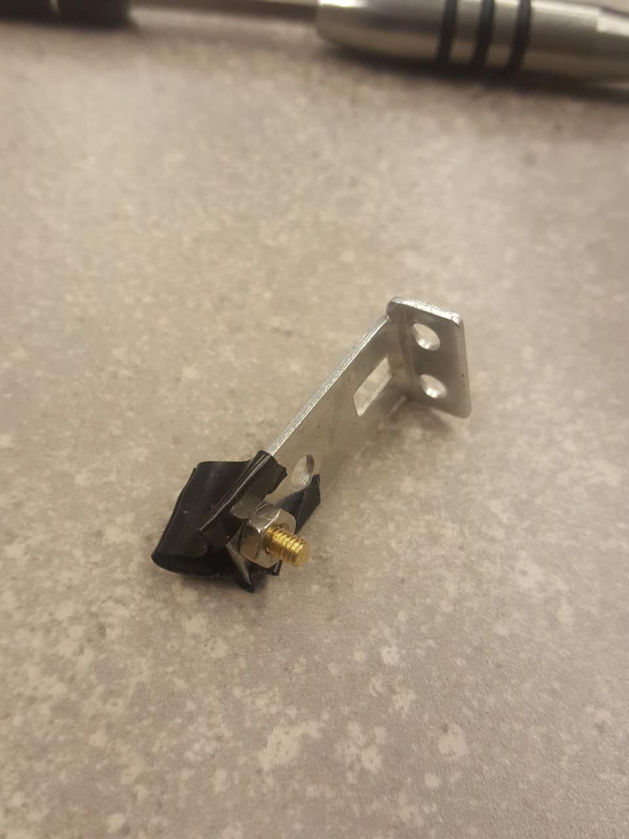

(5)Put it on. The tap is for preventing short circuit.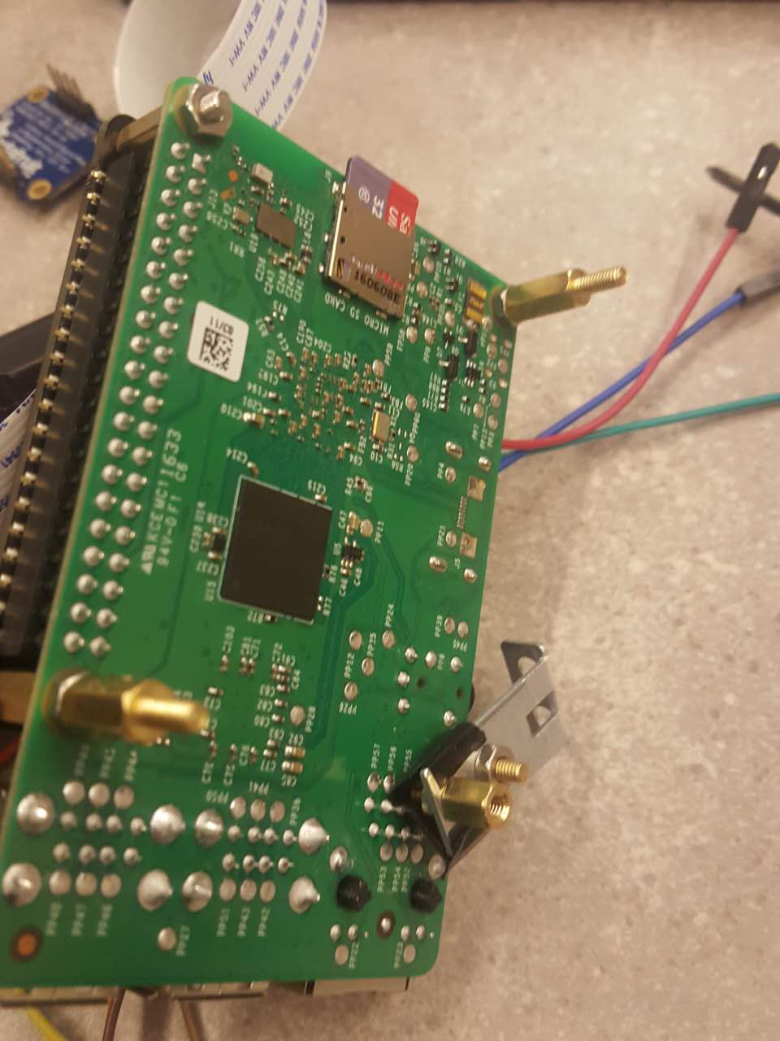

(6)Adjust the location of the T frame to match the open on the drone trail. 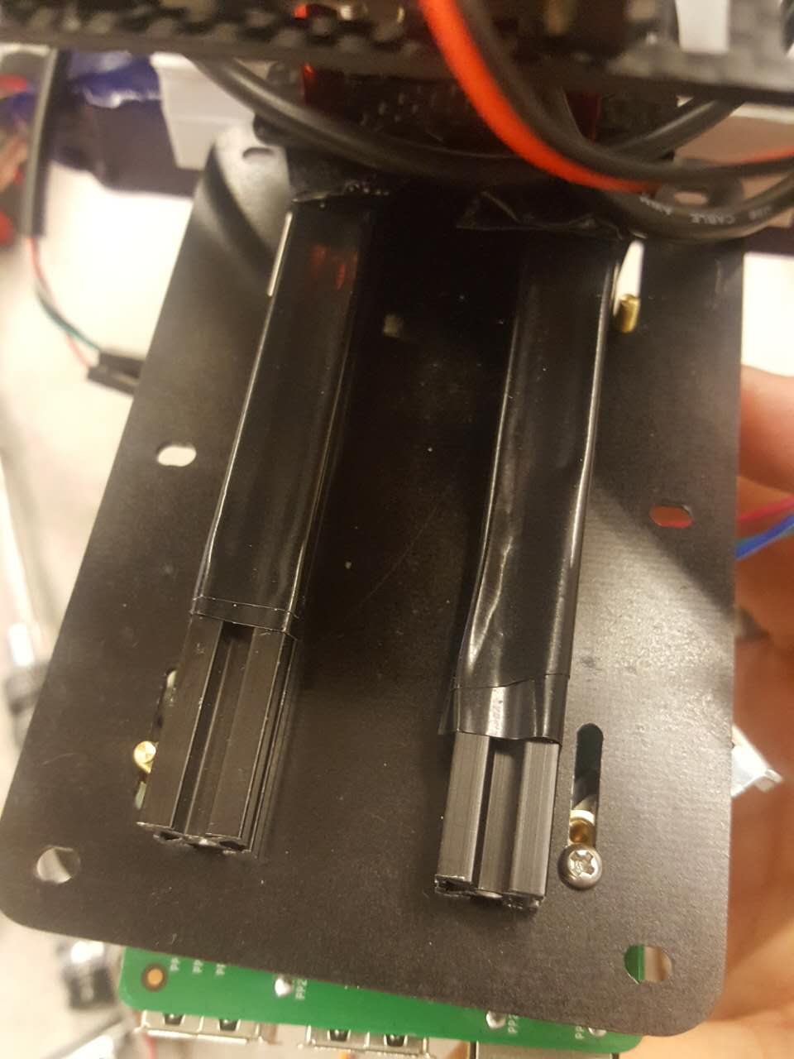

(7)Turning the screw for the right bottom connection, and spacer for the others. 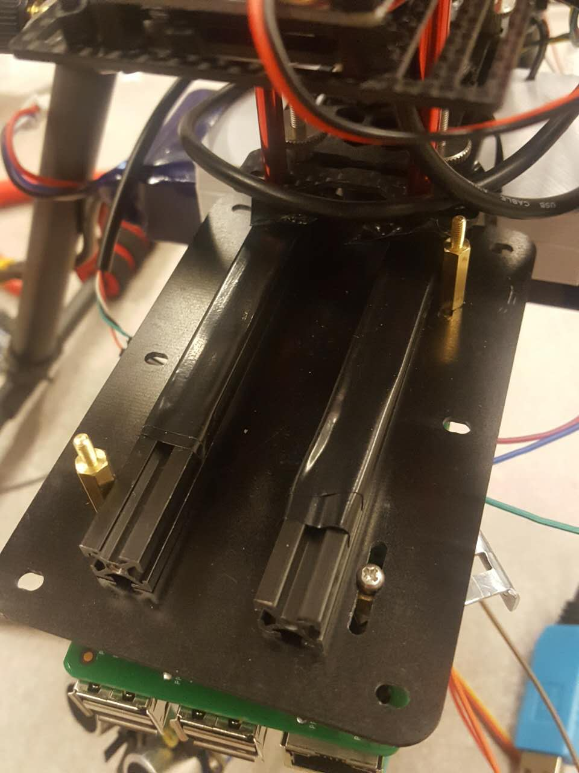

(8)Put the prototype board on the top and put nuts on.

(9)Disassembly follow the reverse order.

**4. Software Setup.**

On this R Pi system all library we need are already installed. I do not suggest you to start on a new system since configure the OpenCV, Drone Kit and other staff take **a lots of time** and there are bunch of bugs and errors that have to be handled properly.

Instead, you can copy the system to a blank SD card using a build-in application in the R Pi os. It is located at: Application menu / Accessories / SD card Copier.

Also notice that drone kit only support python 2.7. So make sure not to use python 3.4.

The opencv is installed on the virtual machine in the system. To use openCV:

In terminal, type ‘source ~/.profile’ enter

Wait and type:

‘workon cv’ enter

Then you will be inside of the virtual machine.

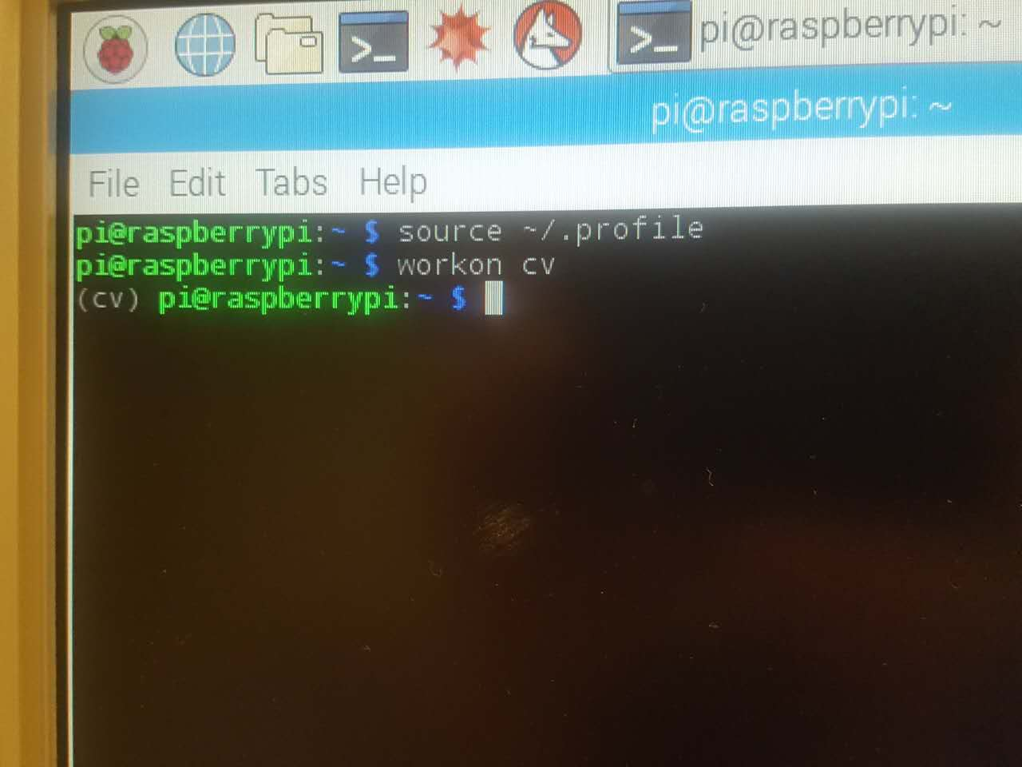

To run some python script, type:

‘python script_name.py’

For all the other linux operation and stuff you need to learn by yourself.

One thing I would like to mention here is how to enable the UART serial port.

To see whether the UART is enabled type:

‘ls /dev/tty*’

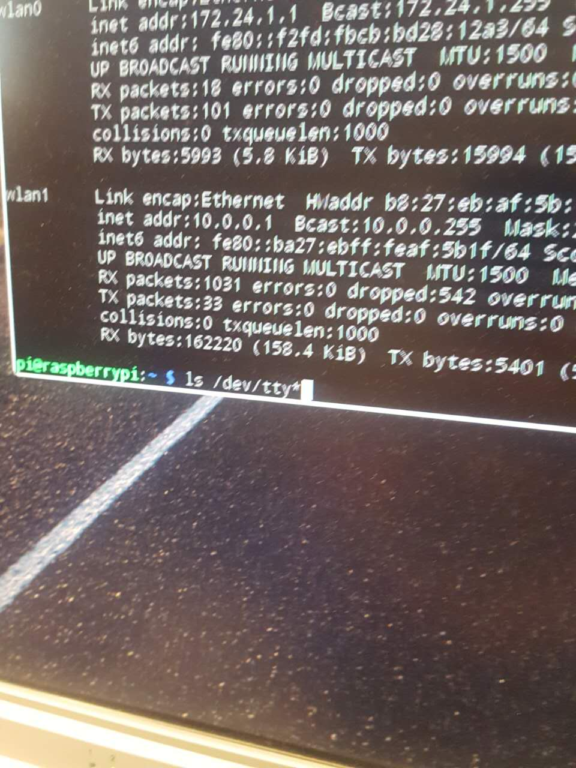

And you will see something like this:

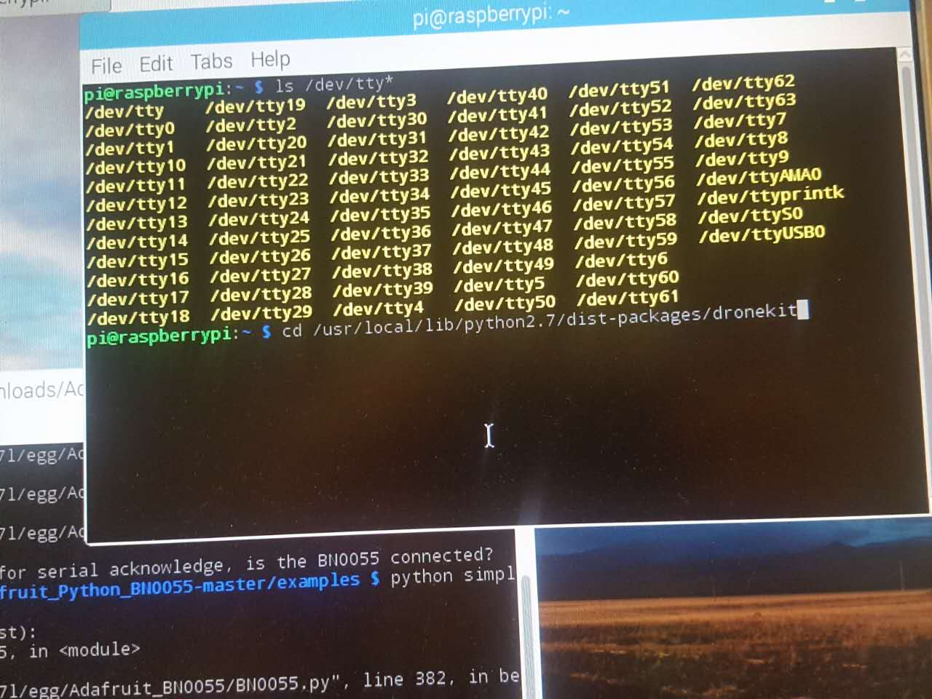

ttyS0 is the normal UART port and USB0 is the added UART port.

If UART is not enabled:

Go to this file:

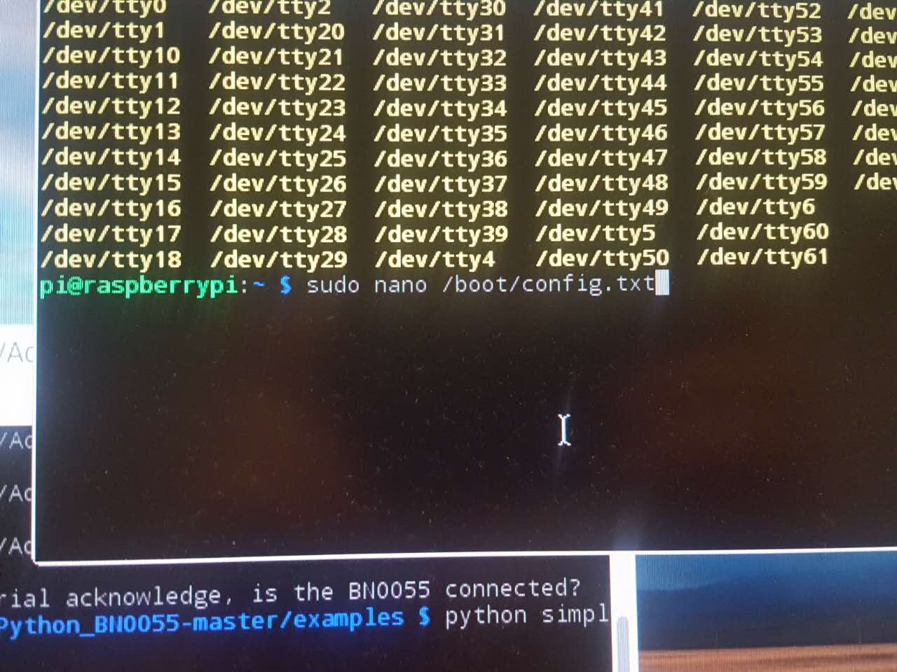

Then change ‘enable_uart=1’

**5. Files brief description:**

In this project I integrated at least 5 different project and bunch of libraries.

Here I will try to describe the function of each file.

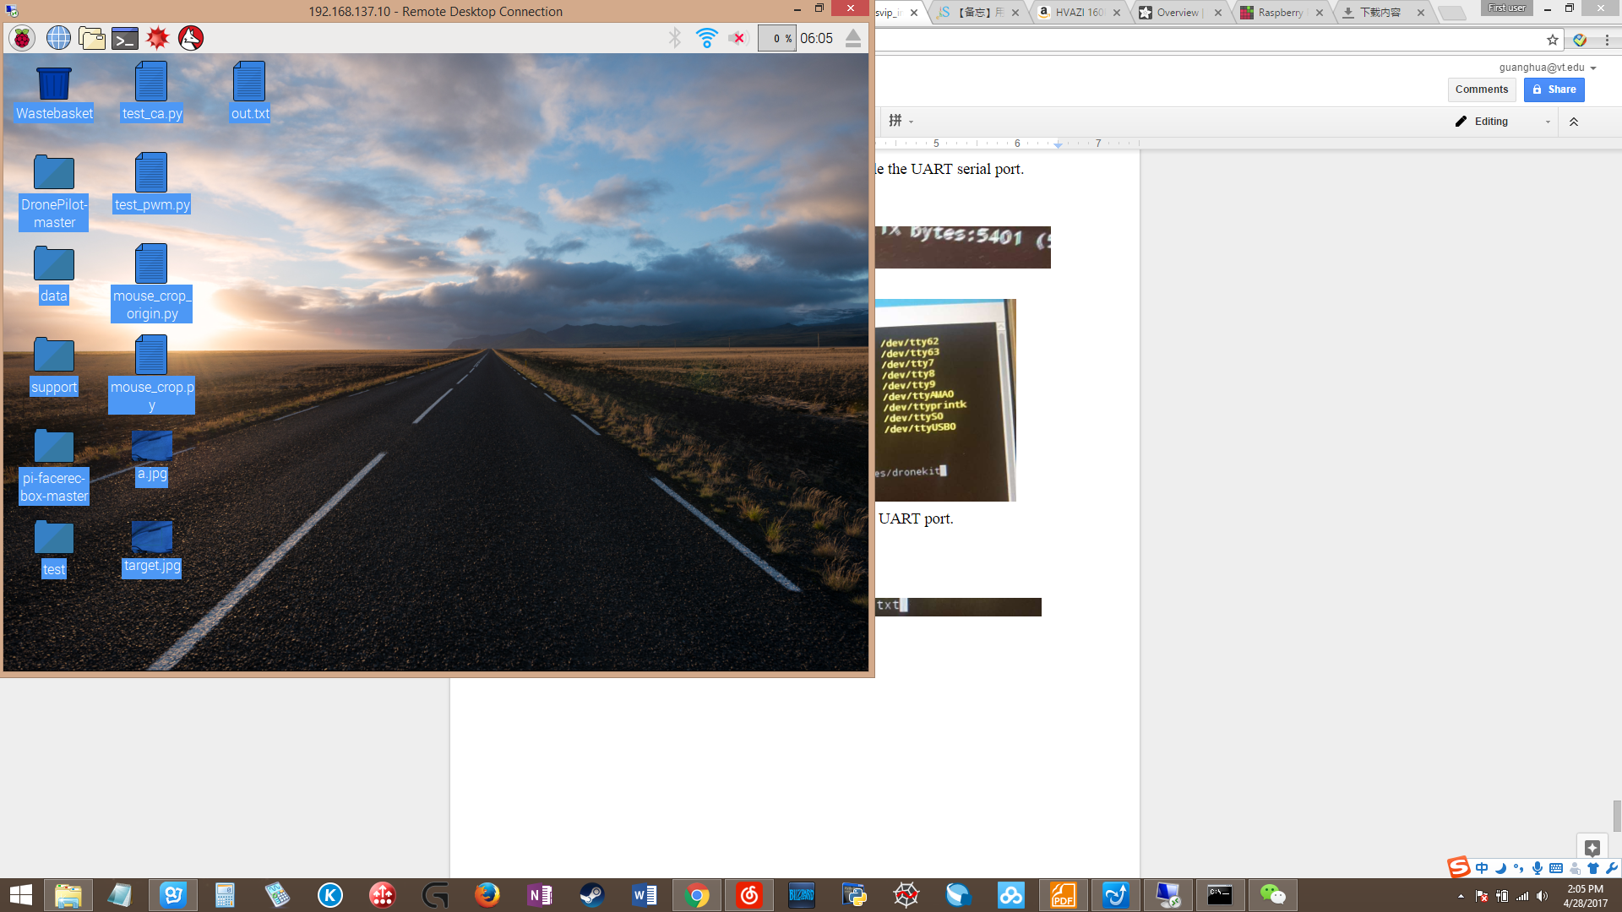

**DronePilot-master:** Code related to drone kit, pixhawk. The file ‘test.py’ in this folder is the script that we actually test with the drone.

**Data:** data that I collected so far.

**Data/dstset:** back projection of images. Produced during tracking.

**Data/negative:** negative faces set.

**Data/tracking_data:** image, back projection, and distance data produced during tracking.

**Data/training_set:** sets of picture and their output from face recognize.

**Support:** some library, and scripts that used in this project.

**Pi-facerec-box-master:** an adafruit project. We used the same method to do the face recognize.

**Test:** all the main script/file located.

**test/face_train.py:** use to take picture of a person. Pictures will be used to produced a module that used in face recognize.

**test/ff0.py:** final script.

**test/integrate.py:** script before final script.

**test/mos_integrate.py:** let user initialize the target using mouse. No face recognition.

**test_ca.py:** test the camera. Take a picture and save it on desktop.

**test_pwm.py:** use the pan-tile module and the distance sensor to collect some data and save it into the out.txt file.

**mos_crop.py:** files that related to mouse click on picture. Need to run with OpenCV.

There is a lot of middle script in the folder test/other. I will not explain them due to the timing issue.

**6. Demo.**

Run the script.

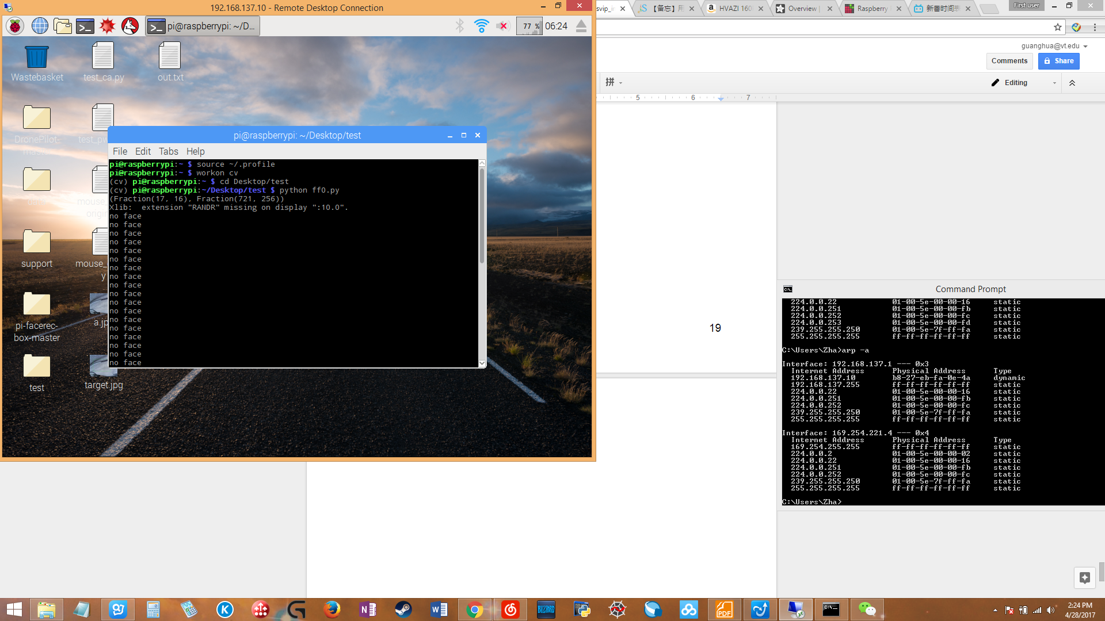

Wait until it find a face and start tracking.

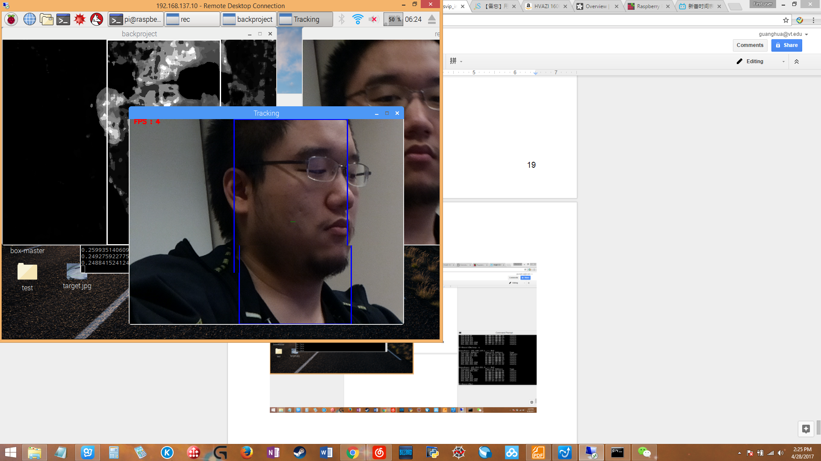

Hit q on the image to stop.

Run the script. Click on two point on the picture. Hit ‘y’ to continue.

Click again to reset. Terminal showing how many points are clicked (0, 1 or 2).

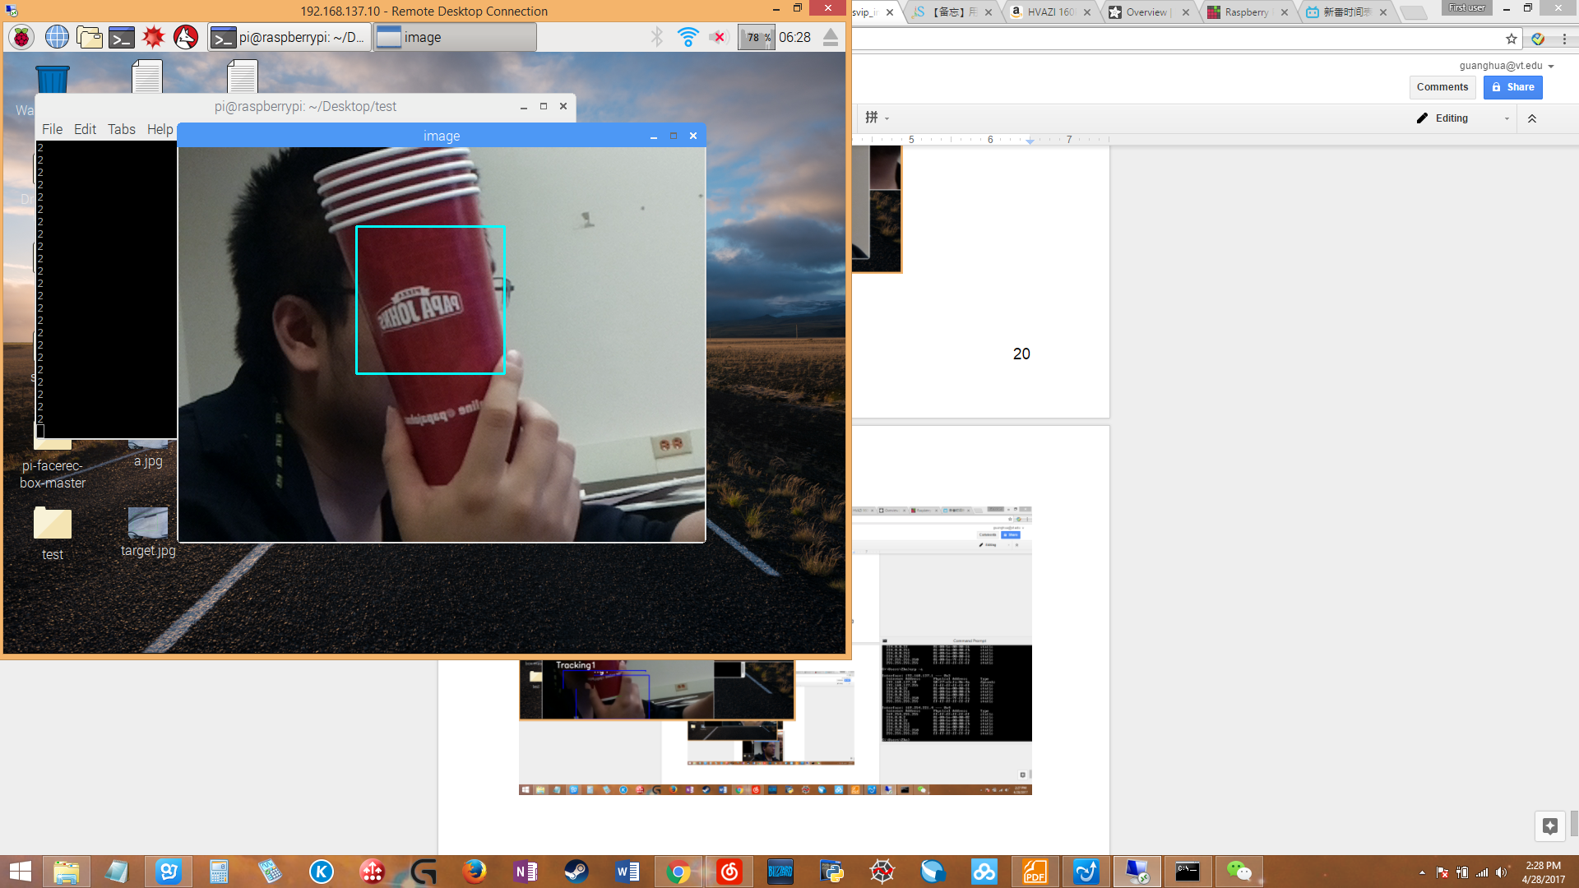

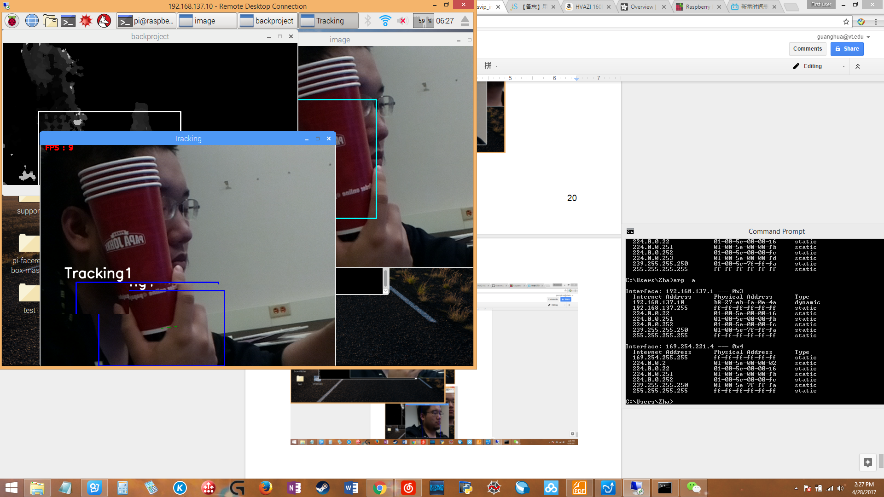

Hit q on image to exit.

**7. Suggestions for future**

During this semester we try the openCV tracking, face detection and integration the R Pi with the drone. After all we had great process, however we also found many unsolved problems. Here I will leave some of my thoughts about this project.

About openCV:

It is a great library since it provide many useful functions and free to use. It use some simple machine learning ideas to achieve the face detection, and color recognize for object tracking.

However, if possible we should replace the openCV with more advanced tool such like tensor flow(TF). We need a fully neural network based tracking tools for the purpose of following people. The openCV method of tracking is unstable and easily affected by environmental such like illumination, and openCV can not handle the waggle cause by the moving drone. Also we did not found a way to recover the tracking if the detector lost the target in half way. In conclusion the openCV is not designed to handle such complicated situation.

About R Pi:

If possible we should replace R Pi with other device. It is an entry level programming device that designed for graphical interface and interaction with sensors. In our project we need more powerful device for image processing. On the other hand we had problem when handle the multi-task. We need to collect data from several sensors while send command to the pixhawk drone also doing the image processing. We currently have all these process in series, since R Pi do not have enough resource to support multi-tasking(For multi-tasking that we suppose to achieve in this project, we need to proceed each part of these job faster with a more powerful core, and move data across different programs without causing any systematics error. Unfortunately both R Pi and python are not designed for such purpose).

Therefore I suggest in future we should buy a new device which is the Intel Euclid development kit.

<https://click.intel.com/intelr-euclidtm-development-kit.html>

This device has several advantage:

Powerful core. Has battery. ROS(robotic operating system) build-in. Some software onboard for robotics development(see from introduction video from youtube). Fish-eye camera, depth camera, and an RGB camera. Build-in motion sensor.

This is one of the best device for robotic development.

It cost $399 and maybe out of stock. But since our target of the project is complicated, we definitely need such a device.

About pan & tilt:

The pan & tilt model that we are using now is not very useful. It can only turing at a fixed angular speed, and cannot follow an object precisely nor keep the camera stable. When the drone is moving the waggle is huge. We need a good pan & tile model to reduce the such impact on the image processing. Otherwise the image processing part will be very unstable.

If you guys keep using the current pan & tilt model, it might be better fix the camera on the drone and not on pan & tilt model. I feel like this pan & tile makes the camera even more unstable.

About control of pixhawk:

During this semester we were able to make the connection between the R Pi and the pixhawk, and we did some test. The result showing that we can send command from R Pi to pixhawk, but we were only able to test two command, takeoff and landing. To actually automatically fly the drone we still need more command such like moving in different direction, rotate, and change altitude.

I talked with Annan Ma about how to automatically fly the drone, and he said there might be a way to simulate a controller in software from a computer to fly the drone instead of using command script. Someone should try this way in future.

About the distance measurement and the navigation:

There is an ultrasonic distance sensor onboard and it is one of the most precise sensor I could found unter $100. Actually the light-lidar sensor is better since it has a longer range and even more precise. The problem with these type of sensor is there has to be positioned right toward the target and also it’s performance of detection unflat target in movement has not been tested yet(maybe doing a sweep in an approximate direction and find the min of all the distance value will be able to solve this problem).

The best distance detection theory I could found is the two cameras visual system and it is actually being used by drone company such like Diji. However, it is very complicated and we cannot make one. If we can achieve this it will make the navigation much simpler.

The current navigation plan is very simple: if we can find the direction of the objective from the image processing, then we can find the distance between the object and our drone using a distance sensor. With direction and distance we get a vector in a plan, then we can make the drone to follow the object while keep the distance within some range(most likely this is determined by the effective range of the distance sensor).

The two main problem we have is: 1. The image processing is not stable. 2. How to command the drone to move in correct direction.

About the Crash:

It happened during our second flight and we were not sure the reason. Here is my guess:

1. Due to low battery. 2. The PID control of the drone is not working correctly. 3. The optic flow sensor not working correctly since we are flying inside.

Anyway, we Still need more test result before we can make any conclusion. Maybe flight in some soft ground place during the following test is a good idea since we cannot predict when will it crash.

In conclusion we are only halfway toward our target. There is still a lots of work need to be done. My final suggestion is: try everything that in your mind. No one knows whether it is achievable or not until you try it out.